


Western Australian Certificate of Education
Course Examination, Sample 2008

Question/Answer Booklet

PHYSICAL EDUCATION STUDIES

Time allowed for this paper
Reading time before commencing work: Ten minutes
Working time for paper: 2 hours and 30 minutes

Materials required/recommended for this paper

To be provided by the supervisor
This Question/Answer Booklet
Multiple-Choice Answer Sheet
Question Sheet for Section Three (inside the front cover of this Question/Answer Booklet)

To be provided by the candidate
Standard items: Pens, pencils, eraser, correction fluid, ruler, highlighter, non-scientific calculator

Special items: Nil

Important note to candidates
No other items may be taken into the examination room. It is your responsibility to ensure that you do not have any unauthorised notes or other items of a non-personal nature in the examination room. If you have any unauthorised material with you, hand it to the supervisor before reading any further.

Structure of this paper

This paper is worth 70 per cent of the total marks in the WACE examination in this course. The remaining 30 per cent of the marks will come from the practical examination in this course.

Section | Number of questions available | Number of questions to be attempted | Suggested working time  (minutes) | Marks available
Section One: Multiple-Choice | 15 | 15 | 20 | 15
Section Two: Short Response  Choose one of these parts:  Option A: 2A/2B Candidates  Option B: 2B/3A Candidates  Option C: 3A/3B Candidates | 3 | 3 | 70 | 45
Section Three: Extended Response | 4 | 2 | 60 | 40
 |  |  | Total | 100

Instructions to candidates

1. The rules for the conduct of Western Australian external examinations are detailed in the TEE/WACE Handbook. Sitting this examination implies that you agree to abide by these rules.

2. Section One: Answer all questions on the separate Multiple-Choice Answer Sheet. Use a blue or black pen or a B or 2B pencil.

3. Section Two: Candidates are required to choose one of the options, according to their final stages of study.

Option A: For candidates who have studied 2A/2B
Option B: For candidates who have studied 2B/3A
Option C: For candidates who have studied 3A/3B

4. Section Three: Questions for this section have been repeated in a removable sheet so that you can refer to them more easily while answering questions. Do not write your answers on the Question Sheet.

5. Write your answers to Section Two and Section Three in this Question/Answer Booklet.

6. Spare pages are provided at the back of this Question/Answer Booklet.

SECTION ONE: MULTIPLE-CHOICE (15 MARKS)

Record an answer for questions 1–15 by marking your choice on the separate Multiple-Choice Answer Sheet using a blue or black pen or a B or 2B pencil. Each question is worth one mark.

If you make an error, follow the instructions given to you on the Multiple-Choice Answer Sheet.

Suggested working time for this section is 20 minutes.

1. “If you don’t use it, you’ll lose it” is a phrase that describes the training principle of

(a) reversibility.
(b) specificity.
(c) quality, not quantity.
(d) progressive overload.

2. If a football player watches his shot at a goal on a video playback, it is a specific example of

(a) terminal feedback.
(b) perceptual mechanism.
(c) concurrent feedback.
(d) effector mechanism.

3. Translation takes place when a body moves, such that all the parts of the body travel exactly the same distance in the same direction and at the same time. Another term to describe this is

(a) angular motion.
(b) momentum.
(c) velocity.
(d) linear motion.

4. The process of setting up how you want a group to interpret an activity is known specifically as

(a) goal setting.
(b) autocratic leadership.
(c) front loading.
(d) debriefing.

5. Carbohydrates consumed in the diet are absorbed in the gut and made available to the blood as

(a) glycerol.
(b) glucose.
(c) glycogen.
(d) lactic acid.

6.
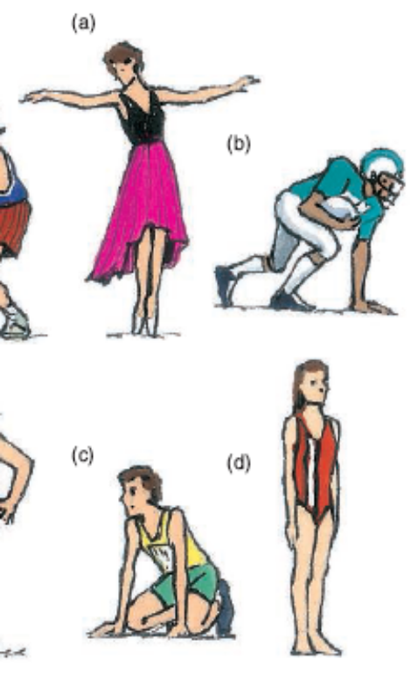
A
B
C
D

Order the positions shown in the drawings above from least stable to most stable.

(a) D B C A
(b) A B C D
(c) D C B A
(d) A D B C

7. The process of responding in precise and appropriate ways to gain cues is known as

(a) Skill analysis
(b) Tactical adjustments
(c) Physical conditioning
(d) Mental adjustment

8. Muscle hypertrophy refers to

(a) an increase in the number of capillaries in a muscle.
(b) an increase in the number of muscle fibres.
(c) an increase in the size of muscle fibres.
(d) the development of slow twitch muscle fibres.

9. Non-specific transfer of learning occurs when

(a) actual skill learning is transferred to another skill.
(b) qualities develop into attitudes and principles for future use.
(c) an experience in a physical activity is applied to another arena.
(d) a conflict between two team members is resolved.

10. Jasmine, a 35-year-old woman, does not do any regular physical activity and has no intention of becoming active in the next six months. Which one of the following strategies would assist Jasmine in moving to the next stage of motivational change?

(a) Encouraging her to be active with a friend.
(b) Teaching her to reward herself for being active.
(c) Increasing her awareness of the risks associated with inactivity.
(d) Encouraging her to set up reminders to be active.
11. What type of attention control does a swimmer need when he is waiting on the blocks ready for the gun to fire?

(a) Broad internal
(b) Broad external
(c) Narrow internal
(d) Narrow external

12. When referring to the summation of forces for maximum force development, which one of the following statements is incorrect?

(a) Each segment must make an optimum contribution before the next body part begins its movement.
(b) As many body parts (segments) as possible must be used.
(c) Body segments are sequenced from small to large.
(d) Preceding body segments must be put on optimum stretch - “the spring coil effect”.

13. Some important chronic effects of a long-term aerobic training program are:

(a) Decreased resting heart-rate and decreased stroke volume during rest.
(b) Increased stroke volume and increased cardiac output during maximal exercise.
(c) Increased maximum heart-rate and increased resting heart-rate.
(d) Increased maximum oxygen uptake and decreased cardiac output during maximal exercise.

14. A batter observes the movement of a ball through the air and adjusts his stroke accordingly. Which characteristic of a performer is this batter demonstrating?

(a) Visualisation
(b) Anticipation
(c) Proprioception
(d) Kinaesthetic sense

15. When referring to general trends in leadership, which one of the following statements is incorrect?

(a) Junior players tend to require more support and encouragement in leadership.
(b) Elite athletes involved in individual activities would prefer a more democratic leadership style.
(c) Male athletes are more receptive to a democratic style of leadership than females, who prefer an autocratic approach.
(d) A laissez-faire approach to training can be useful to encourage a team to develop its own strategies.

END OF SECTION ONE

THIS PAGE HAS BEEN LEFT BLANK INTENTIONALLY

SECTION TWO: SHORT RESPONSE (45 MARKS)

Candidates are required to choose one of the following options, according to their final stages of study. There are three compulsory questions in each option.

Tick one of the boxes below to indicate your choice.

 | P | Pages
Option A: For 2A/2B candidates only |  | 9–14
Option B: For 2B/3A candidates only |  | 16–21
Option C: For 3A/3B candidates only |  | 23–28

Now turn to the relevant pages and answer the questions for the option you have selected.

THIS PAGE HAS BEEN LEFT BLANK INTENTIONALLY

OPTION A: CANDIDATES FOR 2A/2B (45 MARKS)

SECTION 2: SHORT RESPONSE

Only attempt the following questions if you studied units 2A and 2B in 2008.

There are three questions in this section. Attempt all questions.

Write your answers in the spaces provided.

Suggested working time for this section is 70 minutes.

Question 1 (15 Marks)

Refer to the following diagrams, which show an athlete performing the overarm throw on two separate occasions.

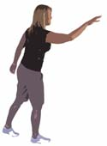
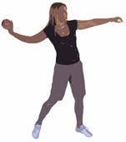
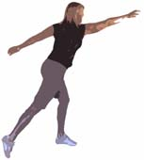
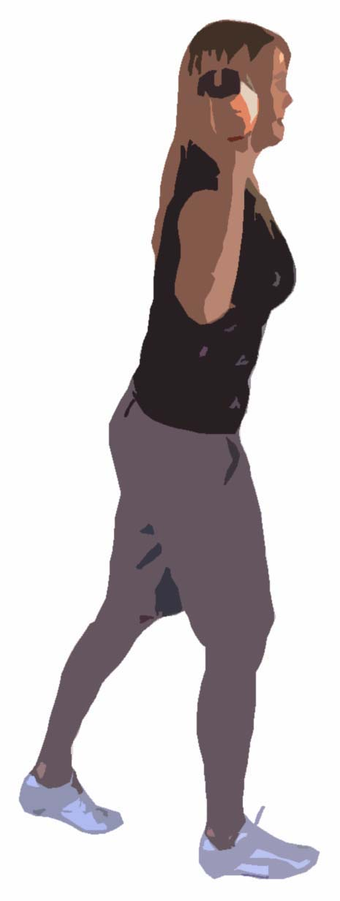
Action A
Action B

(a) Compare the two pairs of diagrams above. Which action (A or B) would enable the person to throw the furthest if all other factors were constant?

(1 mark)
(b) With reference to the diagrams, identify and explain three biomechanical principles that apply to the successful performance of an overarm throw for maximal distance.
(i)

(ii)

(iii)

(6 marks)

(c) Identify four stages in the observation and analysis process for skill development.
(i)

(ii)

(iii)

(iv)

(8 marks)

OPTION A: CANDIDATES FOR 2A/2B

Question 2 (15 Marks)

A state level athlete has been performing below his potential for the last few months and is struggling to make the National squad. The athlete can’t explain his poor form and has asked a senior club member to attend a number of training sessions to see if there are any obvious training issues which may be affecting his performance. The club member notices that the coach speaks to the athlete in a short, sharp dictatorial manner. There is minimal technical instruction or feedback and little direction or focus given to the athlete.

(a) Summarise the style of leadership that has been demonstrated by the coach.

(2 marks)

(b) Describe four qualities a coach may display as an effective leader.
(i)

(ii)

(iii)

(iv)

(4 marks)

- Explain how debriefing could assist the coach to enhance the athlete’s performance.

(3 marks)

(d) Explain what purpose front loading would have in an interaction between this coach and the athlete?

(3 marks)

(e) List three techniques of communication that could be used by the coach to improve her interaction with the athlete.
(i)

(ii)

(iii)

(3 marks)

OPTION A: CANDIDATES FOR 2A/2B

Question 3 (15 Marks)

People often say that sport is ‘10% physical and 90% mental’. It is not uncommon for individuals or teams that are losing at half time or part way through a match to win the game. Mentally these athletes must be able to remain focussed throughout the entire match.

(a) Outline the difference between short and long term goals with reference to the situation described above and a sport of your choice.

(3 marks)

(b) For the situation described above, it will be extremely important that all team members remain in their optimal arousal zone. Explain the arousal zones of the Inverted U Hypothesis and the impact these have on performance.

(6 marks)
(c) At half time, if athletes are feeling overwhelmed or are concerned with their poor judgements on the field, they may need to undertake some relaxation. Briefly explain three types of relaxation that could be used in this situation.
(i)

(ii)

(iii)

(3 marks)

(d) A coach believes that an umpire has unfairly penalised her team in the first half and is causing it to lose. Describe three problems that could arise for the losing athlete’s mental set if a coach focuses on the perceived poor umpiring decisions in her half time address.
(i)

(ii)

(iii)

(3 marks)

END OF SECTION 2 FOR OPTION A CANDIDATES

TURN TO PAGE 31 FOR SECTION THREE
OPTION B: CANDIDATES FOR 2B/3A (45 MARKS)

SECTION 2: SHORT RESPONSE

Only attempt the following questions if you studied units 2B and 3A in 2008.

There are three questions in this section. Attempt all questions.

Write your answers in the spaces provided.

Suggested working time for this part is 70 minutes.

Question 1 (15 Marks)

People often say that sport is ‘10% physical and 90% mental’. It is not uncommon for individuals or teams that are losing at half time or part way through a match to win the game. Mentally these athletes must be able to remain focussed throughout the entire match.

(a) Outline the difference between short and long term goals with reference to the situation described above and a sport of your choice.

(3 marks)

(b) For the situation described above, it will be extremely important that all team members remain in their optimal arousal zone. Explain the arousal zones of the Inverted U Hypothesis and the impact these have on performance.

(6 marks)
(c) At half time, if athletes are feeling overwhelmed or are concerned with their poor judgements on the field, they may need to undertake some relaxation. Briefly explain three types of relaxation that could be used in this situation.
(i)

(ii)

(iii)

(3 marks)

(d) A coach believes that an umpire has unfairly penalised her team in the first half and is causing it to lose. Describe three problems that could arise for the losing athlete’s mental set if a coach focuses on the perceived poor umpiring decisions in her half time address.
(i)

(ii)

(iii)

(3 marks)

OPTION B: CANDIDATES FOR 2B/3A

Question 2 (15 Marks)

The graph below shows the relationship between the number of motor units contracting and the total tension developed in a muscle from three different athletes (A, B, C).

Tension (kg)
or strength
300

250

200

150

100

50
50100150200250300
Number of motor units contracting
0
A
B
C

(a) Describe the effect of increasing the number of motor units contracting on the potential to develop muscle tension.

(1 mark)

(b) Identify which line best represents a strength-trained athlete and explain your answer.

(2 marks)

(c) The coach of a weightlifter is training to peak her athlete for a major competition. Outline the application of peaking and periodisation and how they would underpin the training program to ensure that the athlete peaks at the right time and avoids overtraining.

(4 marks)

(d) List four variables that you would monitor as indicators of overtraining and explain what you would be looking for in each observation.
(i)

(ii)

(iii)

(iv)

(v)

(vi)

(vii)

(viii)

(8 marks)

OPTION B: CANDIDATES FOR 2B/3A

Question 3 (15 Marks)

An Indigenous athlete living away from home for the first time is struggling to achieve in an Australian Football League (AFL) team and to cope with the lifestyle changes involved.

As the coach of this athlete, suggest three ways you may manage change in each of the following areas to support him to reach his goal of being successful both on and off the field.

(i) Economic
(ii) Social
(iii) Cultural
(iv) Emotional
(v) Physical
(i)

(ii)

(iii)

(iv)

(v)

(10 marks)

END OF SECTION 2 FOR OPTION B CANDIDATES

TURN TO PAGE 31 FOR SECTION THREE

OPTION C: CANDIDATES FOR 3A/3B (45 MARKS)

SECTION 2: SHORT RESPONSE

Only attempt the following questions if you studied units 3A and 3B in 2008.

There are three questions in this section. Attempt all questions.

Write your answers in the spaces provided.

Suggested working time for this part is 70 minutes.

Question 1 (15 Marks)

An Indigenous athlete living away from home for the first time is struggling to achieve in an Australian Football League (AFL) team and to cope with the lifestyle changes involved.

As the coach of this athlete, suggest three ways you may manage change in each of the following areas to support him to reach his goal of being successful both on and off the field.

(i) Economic
(ii) Social
(iii) Cultural
(iv) Emotional
(v) Physical
(i)

(ii)

(iii)

(iv)

(v)

(10 marks)

OPTION C: CANDIDATES FOR 3A/3B

Question 2 (15 Marks)

It can be said that: ‘A champion team will always beat a team of champions.’

(a) Define group cohesion.

(2 marks)

- Identify the four factors outlined in Carron’s model that may affect group cohesion. Give an example for each factor.
(i)

(ii)

(iii)

(iv)

(8 marks)
- Identify five things a coach can do to build group cohesion.
(i)

(ii)

(iii)

(iv)

(v)

(5 marks)
OPTION C: CANDIDATES FOR 3A/3B

Question 3 (15 Marks)

Tennis player Maria Isitallova won a record 167 singles titles and 172 doubles titles. Seventeen years later she again competed in events on the women’s tour at the age of 47.

The following changes occur with ageing and will have decreased Maria’s aerobic capacity and performance. Explain how each of these factors will lead to a decrease in aerobic capacity.

(a) Decreased size and number of skeletal muscle mitochondria

(2 marks)

(b) Decreased stroke volume

(2 marks)

(c) Decreased capillarisation

(2 marks)

(d) Identify three other physiological changes Maria may experience due to aging.
(i)

(ii)

(iii)

(3 marks)
Maria has spent her life playing and training at or around sea-level. In the modern era she must play a series of qualifying tournaments at various remote high altitude locations designed to broaden the tennis market.

(e) Identify three key physiological changes that occur when competing at high altitude. What effect will each have on her performance?
(i)

(ii)

(iii)

(6 marks)

END OF SECTION 2 FOR OPTION C CANDIDATES

TURN TO PAGE 31 FOR SECTION THREE

THIS PAGE HAS BEEN LEFT BLANK INTENTIONALLY

SECTION THREE: EXTENDED RESPONSE
FOR ALL CANDIDATES (40 MARKS)

Choose only two of the following four questions to answer.

Write your answer on the lined pages provided.

Suggested working time for this section is 60 minutes.

Question 1 (20 Marks)

Paceman’s physical and emotional battle with injury takes toll

For copyright reasons this article cannot be reproduced in the online version of this document.

Adapted from an article in the West Australian newspaper, January 2008

In relation to this sudden announcement of a highly talented young cricketer’s retirement:

(a) Identify and explain the impact of a key physical, mental and social factor that played a role in this particular case of burnout.
(6 marks)

(b) As his coach, develop and justify holistic strategies to facilitate both his mental and physical recovery to play elite cricket again, including:
- goal setting
- managing stress and anxiety
- decision making
(7 marks)
(c) You attended a recent coaches’ conference at which a key topic of discussion was
‘Cricket authorities do not and should not have a role in player burnout’. Present an argument against this proposition by addressing factors related to holistic, long term player wellbeing, including codes of ethics in sport.
(7 marks)

OR

Question 2 (20 Marks)

Using your knowledge of environmental conditions, select an outdoor team sport that you are familiar with and explain how you would adjust your skills, tactics and strategies to optimise your performance in the following situations:

- wet weather
- hot, dry conditions
- freezing conditions
- windy conditions

OR

Question 3 (20 Marks)

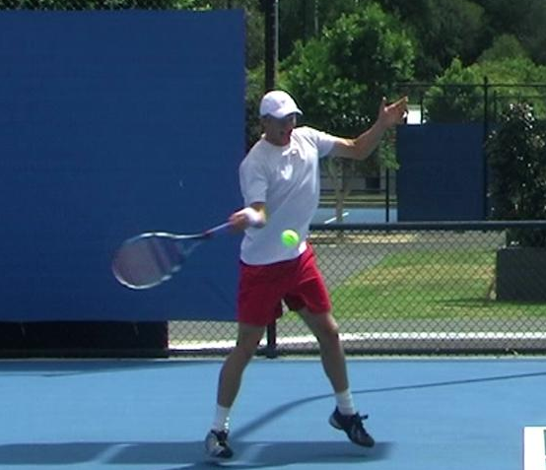

(a) Describe the optimal sequencing of body parts involved in performing a well coordinated tennis forehand stroke as shown in the picture above. Integrate movement (biomechanical) principles into the optimal sequencing that you suggest to help justify your answer.
(5 marks)

(b) Hitting the forehand with topspin can make a ball’s trajectory change compared to hitting the ball with backspin or with no spin. Draw a graph showing the expected trajectories of tennis balls hit with topspin, backspin and no spin (assume all other factors contributing to ball trajectory are constant). (5 marks)

Explain the different trajectories using movement (biomechanical) principles (you may use diagrams to illustrate your response).
(10marks)
OR

Question 4 (20 Marks)

Volleyball is a net-divided team game in which players attempt to score points by hitting the ball into the unguarded spaces of the opponent’s court. Players who form the team require a number of key physical variables such as hand-eye coordination, reaction time, anticipation, agility and leg power.

Table 1

(a)
(3 marks)

For copyright reasons some parts of question 4 cannot be reproduced in the online version of this document, but can be viewed on page 15 & 16 of website: http://www.vcaa.vic.edu.au/vce/studies/physicaledu/pastexams/2003_physed.pdf

Table 2

(b) (2 marks)

(c)

(6 marks)

(d) An analysis of the athlete’s movement on court identifies relatively poor agility.
The coach decides to include martial arts and running as part of the athlete’s agility conditioning program. Discuss how these additional activities improve the player’s agility by referring to the following coaching and learning principles.

- Specificity of training (2 marks)

- Cross training (2 marks)

- Transfer of training (2 marks)

(e) To prepare the team for the upcoming national championships the coach devises simulation drills. Define what is meant by simulation drills and explain why the coach would use simulation drills.
(3 marks)

END OF QUESTIONS

ACKNOWLEDGEMENTS
Published by the Curriculum Council of Western Australia
27 Walters Drive
OSBORNE PARK WA 6017

SECTION ONE

Question 1 Adapted from: Tasmanian Qualifications Authority. (2006). Sport Science: Senior
Secondary 5C: External assessment 2006 (p. 7). Retrieved February, 2008, from
http://www.tqa.tas.gov.au/1077 .

Question 5 Fankhauser, G., & Jamison, B. (1986). Year 12 physical education: Exam questions by
topics. Malvern, Vic.: Coghill, p. 39.

Question 6 Diagram from: Smyth, D., Brown, H., Judge, W., McCallum, C., & Wright, P. (2006).
Live it up 1 (2nd ed.). Milton, Qld: John Wiley & Sons Australia, Ltd, p. 93.
© Reprinted with permission of John Wiley & Sons Australia.

Question 9 Adapted from: Victorian Curriculum and Assessment Authority. (2006). Physical
Education: Writtten examination: Victorian Certificate of Education 2006 (p. 5).
Retrieved February, 2008, from
http://www.vcaa.vic.edu.au/vce/studies/physicaledu/exams.html.

Question 13 Senior Secondary Assessment Board of South Australia. (2004). 2004 Physical
Education: Public examination 2004 (p. 4). Retrieved February, 2008, from
http://www.ssabsa.sa.edu.au/ex-2004.htm.

SECTION THREE

Question 1 Adapted from: Johnson, L. (2008, January 30). Tait grinds to a halt. Paceman’s physical and emotional battle with injury takes toll, The West Australian, p. 114.

Question 4 Adapted from: Victorian Curriculum and Assessment Authority. (2003). Physical Education: Written examination: Victorian Certificate of Education 2003 (pp. 15–16). Retrieved February, 2008, from http://www.vcaa.vic.edu.au/vce/studies/physicaledu/exams.html .

